# Database Programming with SQL

**9-1: Using GROUP BY and HAVING Clauses**

1. In the SQL query shown below, which of the following is true about this query?
   1. Kimberly Grant would not appear in the results set.
   2. The GROUP BY clause has an error because the manager_id is not listed in the SELECT clause.
   3. Only salaries greater than 16001 will be in the result set.
   4. Names beginning with Ki will appear after names beginning with Ko.
   5. Last names such as King and Kochhar will be returned even if they don’t have salaries > 16000.

SELECT last_name, MAX(salary)

FROM employees WHERE last_name LIKE 'K%'

GROUP BY manager_id, last_name

HAVING MAX(salary) >16000

ORDER BY last_name DESC ;

**None of the statements are True**

1. Each of the following SQL queries has an error. Find the error and correct it. Use Oracle Application Express to verify that your corrections produce the desired results.
2. SELECT manager_id FROM employees WHERE AVG(salary) < 93;

**SELECT manager_id FROM employees GROUP BY manager_id HAVING AVG(salary) < 93;**

1. SELECT cd_number, COUNT(title) FROM d_cds WHERE cd_number < 93;

**SELECT cd_number, COUNT(title) FROM d_cds WHERE cd_number < 93 GROUP BY cd_number;**

1. SELECT ID, MAX(ID), artist AS Artist FROM d_songs WHERE duration IN('3 min', '6 min', '10 min') HAVING ID < 50 GROUP by ID;

**SELECT MAX(ID) AS max_id, artist AS Artist FROM d_songs WHERE duration IN ('3 min', '6 min', '10 min') GROUP BY artist HAVING MAX(ID) < 50;**

1. SELECT loc_type, rental_fee AS Fee FROM d_venues WHERE id

**SELECT loc_type, rental_fee AS Fee FROM d_venues WHERE id IS NOT NULL;**

1. Rewrite the following query to accomplish the same result: SELECT DISTINCT MAX(song_id) FROM d_track_listings WHERE track IN ( 1, 2, 3);

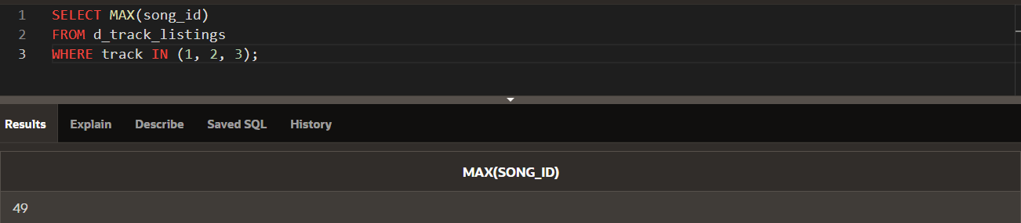

1. Indicate True or False
2. If you include a group function and any other individual columns in a SELECT clause, then each individual column must also appear in the GROUP BY clause. **(True)**
3. You can use a column alias in the GROUP BY clause. **(False)**
4. The GROUP BY clause always includes a group function. **(False)**
5. Write a query that will return both the maximum and minimum average salary grouped by department from the employees table.

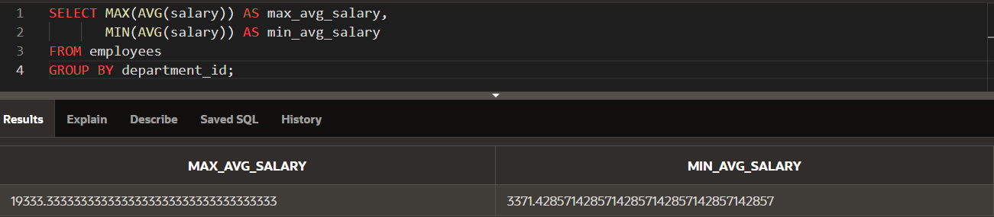

1. Write a query that will return the average of the maximum salaries in each department for the employees table.

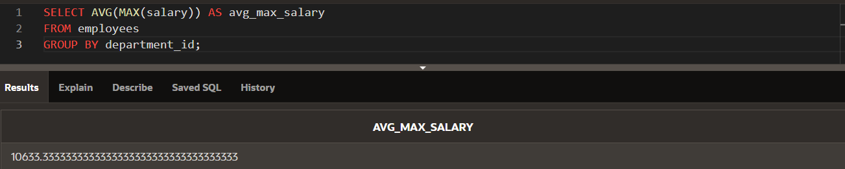

**9-2: Using ROLLUP and CUBE Operations and GROUPING SETS**

1. Within the Employees table, each manager_id is the manager of one or more employees who each have a job_id and earn a salary. For each manager, what is the total salary earned by all of the employees within each job_id? Write a query to display the Manager_id, job_id, and total salary. Include in the result the subtotal salary for each manager and a grand total of all salaries.

* You can use the ROLLUP operation to get the total salary for each manager_id and job_id, along with the subtotals for each manager_id and a grand total.

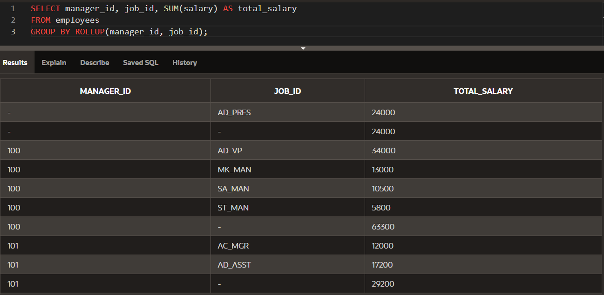

1. Amend the previous query to also include a subtotal salary for each job_id regardless of the manager_id.

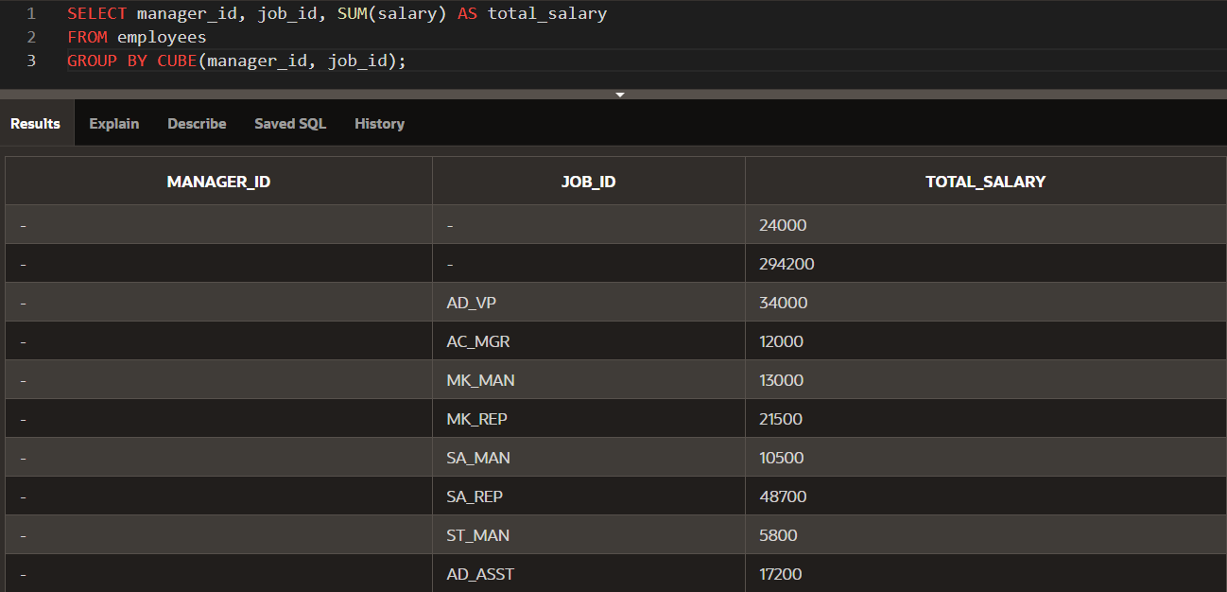

1. Using GROUPING SETS, write a query to show the following groupings:

* department_id, manager_id, job_id
* manager_id, job_id
* department_id, manager_id

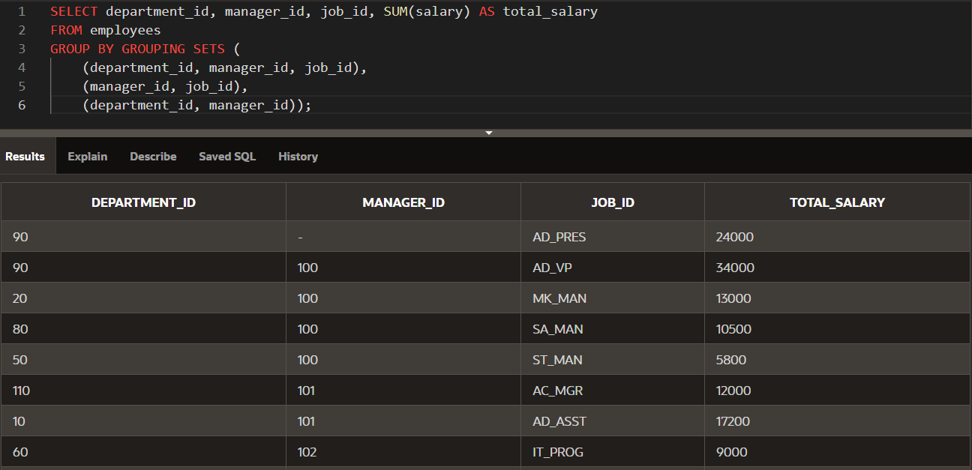

**9-3: Set Operators**

1. Name the different Set operators?

* **UNION**: Combines results of two queries, removing duplicates.
* **UNION ALL**: Combines results of two queries, including duplicates.
* **INTERSECT**: Returns only the rows that are common between two queries.
* **MINUS**: Returns the rows from the first query that are not present in the second query.

1. Write one query to return the employee_id, job_id, hire_date, and department_id of all employees and a second query listing employee_id, job_id, start_date, and department_id from the job_history table and combine the results as one single output. Make sure you suppress duplicates in the output.

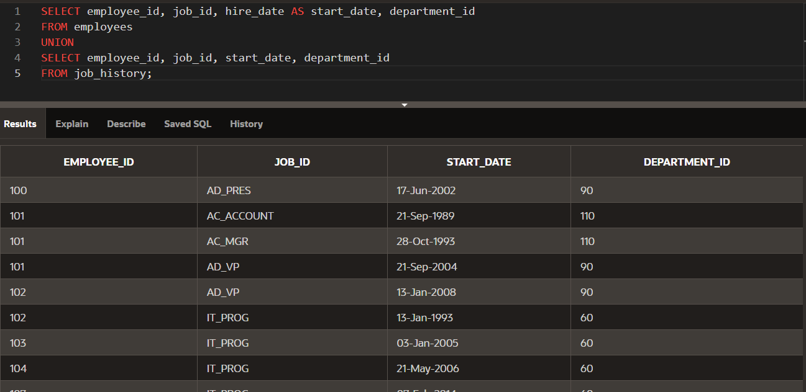

1. Amend the previous statement to not suppress duplicates and examine the output. How many extra rows did you get returned and which were they? Sort the output by employee_id to make it easier to spot.

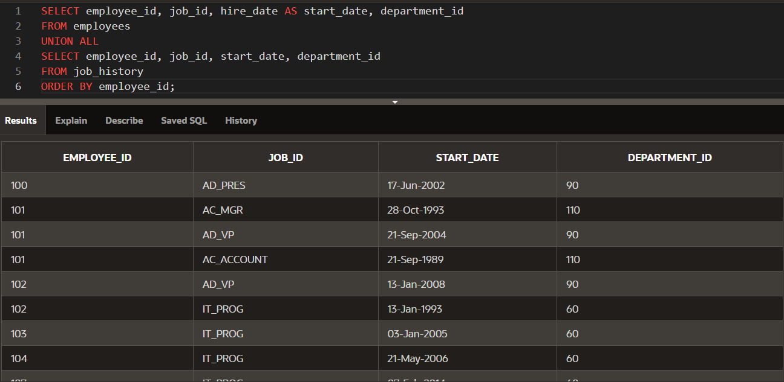

1. List all employees who have not changed jobs even once. (Such employees are not found in the job_history table)

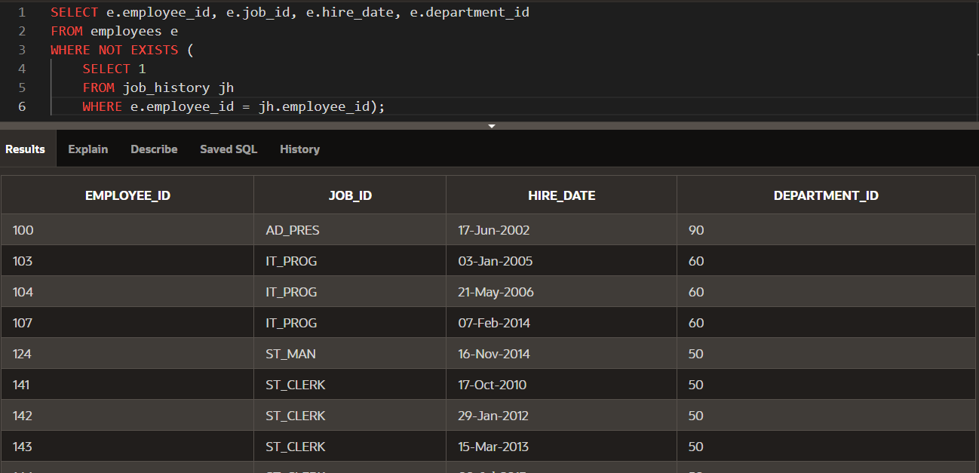

1. List the employees that HAVE changed their jobs at least once.

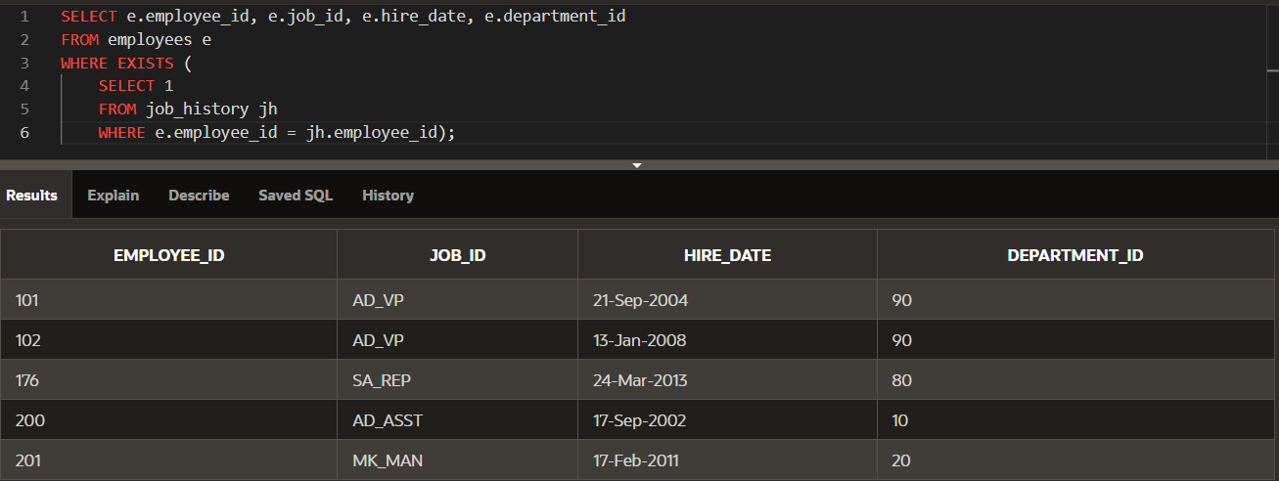

1. Using the UNION operator, write a query that displays the employee_id, job_id, and salary of ALL present and past employees. If a salary is not found, then just display a 0 (zero) in its place

